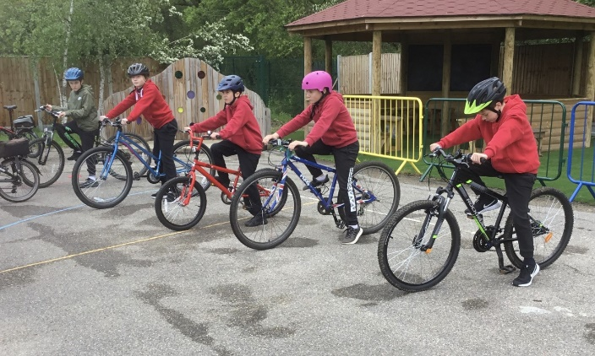

**Outstanding Commitment to**

**HEALTHY SCHOOLS AWARD**

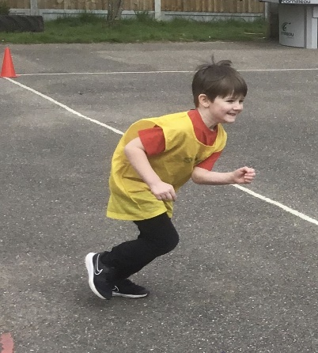

**More tournaments attended**

**Links with Basildon Sporting Village for swimming**

**Minimum of 2 hours of Curriculum PE each week**

**GOLD**

**Schools Games Mark**

**2020/21**

**More after school clubs**

Qualified Sports Coach

**100% of pupils using The Daily Mile**

**86%**

of our Year 6 Swimmers leave achieving their 25m+ certificate.